# Example Setup

Mainline Configuration

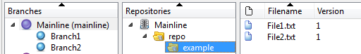

Branch1 Configuration

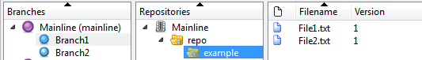

Branch2 Configuration

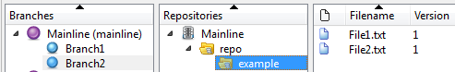

# Example Process

1. Edit Branch1’s ‘Mainline/repo/example/File1.txt’  
   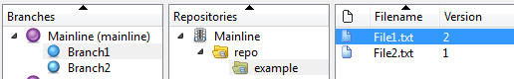
2. Rename Branch1’s ‘Mainline/repo/example’ to ‘Mainline/repo/newName’  
   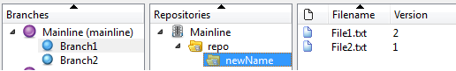
3. Promote changes from Branch1 to Mainline  
   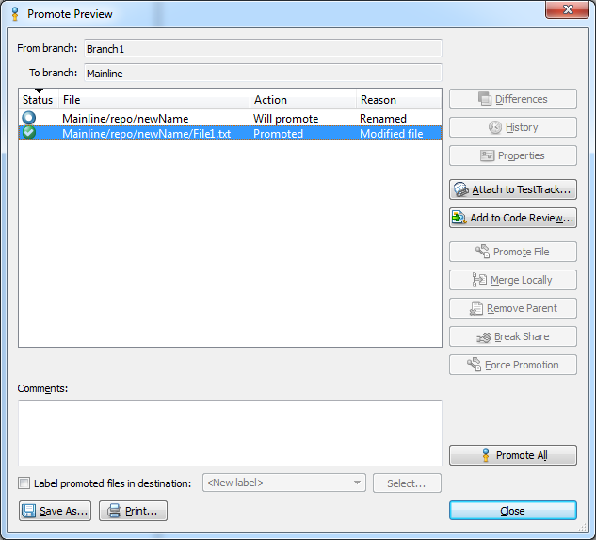  
   Notice, since File1.txt on Branch1 and Mainline are the same file, changes from ‘newName/File1.txt’ on Branch1 are promoted to ‘example/File1.txt’ on the Mainline.  
   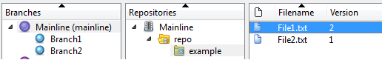

# Discussion of the Example

For this customer, they are essentially in the state described in the example. The difference is that they want to create the equivalent of a repository named ‘newName’ on Branch2 and are getting the error:   
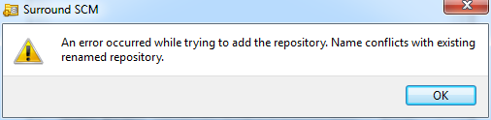

The reason the user is getting this error is because as the example illustrated, the Surround SCM Server knows that historically, ‘newName’ and ‘example’ are the same repository and ‘example’ already exists on Branch2.

If we allowed a user to create a repository named ‘Mainline/repo/newName’ on the mainline (or any other branch), when a user tries to promote up changes from Branch1, what would the customer expect to happen? Where would the changes to ‘Mainline/repo/newName/File1.txt’ from Branch1 be promoted too? Historically, they are the same file as ‘Mainline/repo/example/File1.txt’ on the mainline, but the user also created a repository path ‘Mainline/repo/newName’ as well. Would the SCM Server maintain the historical connection and promote the changes into example/File1.txt? Or would it promote a new file to ‘Mainline/repo/newName’?

To prevent that situation occurring, the Surround SCM Server blocks the creation of a conflicting repository path.

We can enter a feature request to modify the current behavior, and if the user has an idea for how it can be done without breaking the association of files between branches, then we will definitely take it under consideration.